10.17结果分析

## Result analysis

r2=r2*1.13

Dosage: B. S 0.1 g/L, N. SP 0.2 g/L.

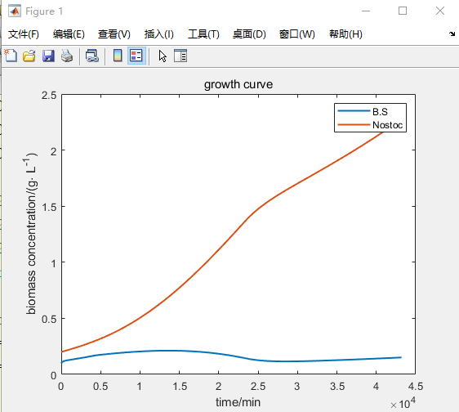

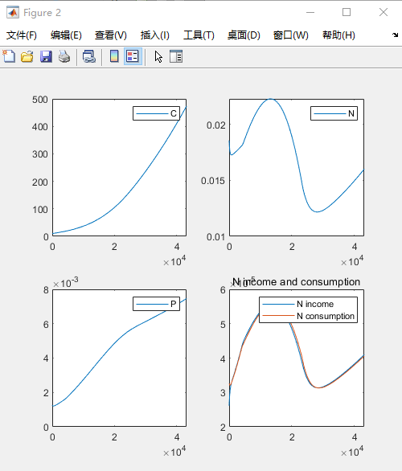

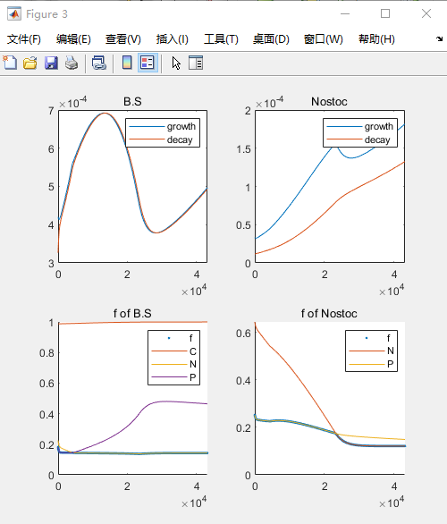

In the beginning, both B. S. and N.sp will be limited by P resources, and the two organisms will grow slowly temporarily. However, P concentration will continue to increase with the phosphorus dissolution of B.S. Therefore, the restriction on B.S quickly changed from P to N and reduced the restriction on P of N.sp to a certain extent. N.sp keeps growing faster. The rapid growth of N.sp leads to large consumption of N, and the resource of N tends to decline on the 16th day. B.S was restrained by competition of N and The fBS decreases slowly, biomass gradually decreased after reaching its peak.   
With the consumption of N, N replaces P to limit the growth of N.sp on the 16th day, and the growth rate of N.sp decreases(an obvious turning point on the 16th day). The biomass of B.S reached the lowest, and the N limitation became smaller, fBS increases slowly. This allows B.S to grow again and makes the amount of N resources rise. Eventually, both B.S. and N.sp can achieve a steady growth trend, and various resources can also rise steadily.

### 变异系数分析

* r1和r2、m2的影响都较小；Pf，Nf1，m1的影响较大
* m1相比于m2的Cv大很多

我们通过输入正态分布的某一参数，然后分析输出的变异系数（这反映了输出值的分散情况）发现Pf，Nf1，m1比r1和r2、m2对输出有更大的影响。

By inputting a certain parameter of the normal distribution, and analyzing the coefficient of variation of the output (which reflects the dispersion of the output values), we find that Pf, Nf1, and m1 have a greater impact on the output than r1, r2, and m2.

### Morris分析

（具体数值实际上与选取的时间有关，没有分析）

溶磷速率

菌先正后负最后**趋近于0**，快速进入氮限制

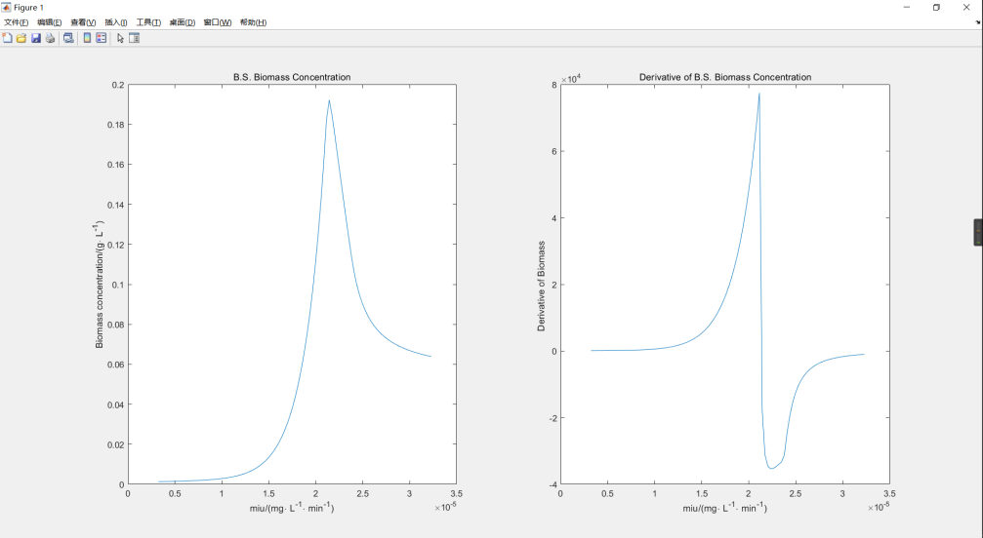

藻先增后降，一直是正

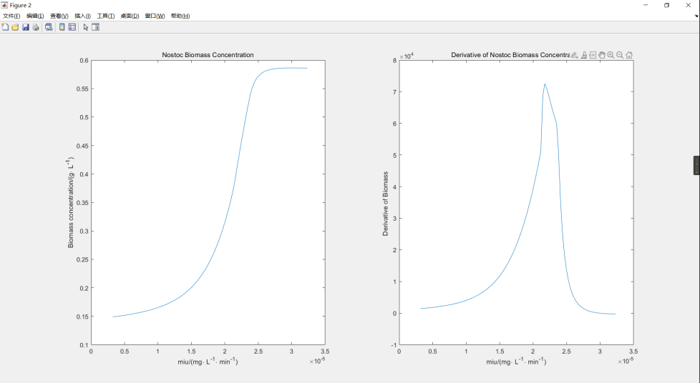

* 不太高的话，随着增加，菌和藻的量都会增加
  + 因为早期两者都是P限制
* 过于高的话，使早期蓝藻快速繁殖，对菌产生抑制，会较少很多（N限制竞争）
  + 菌快速进入氮限制，蓝藻竞争N
  + 藻会长的更快些，但逐渐趋近饱和（受到的影响不会太大了）
* 最终，导数趋近0
  + 增加太多，刚开始长的快，但是到N限制很快下降，变化不大。提前进入N下降阶段，进入稳定阶段
  + 基本上是快速过渡到N限制

较快的溶磷速率可以减缓B.S和N.sp早期受到的P限制。超过某一阈值后，由于N限制阶段提前到来，快速增长的N.sp通过对N的竞争抑制B.S的生长，这种影响会逐渐趋于平缓。

A faster phosphorus dissolution rate could alleviate the p-limitation experienced by B.S and N.sp at an early stage. After exceeding a certain threshold, due to the early arrival of the N-limiting stage, the fast-growing N.sp inhibits the growth of B.S by competing for N, and this effect will gradually flatten out.

溶氮速率

* 高于2.7，无氮限制阶段，全程为磷限制**（导数为0）**
* 较低的时候，菌导数为正，氮倒数为负
  + 猜：菌更晚进入氮限制阶段，所以受到限制更低，长得多
  + 藻：更晚进入氮限制阶段，但菌的生长加快消耗P，使蓝藻长得变慢

较高的氮矿化速率使B.S和N.sp更晚进入N限制阶段，没有及时受到N限制的B.S会有更高的生长率，并通过对P的竞争抑制了蓝藻的生长。当氮矿化速率增加到一定值，N限制阶段将完全被解除，生长情况不再变化。

A higher nitrogen mineralization rate allowed B.S. and N.sp to enter the N-limiting stage later. B.S. without timely N-limiting would have a higher growth rate and inhibited the growth of N.sp by competing for P. When the nitrogen mineralization rate increases to a certain value, the N-limiting stage will be completely lifted and the growth condition will not be changed.